CSA1708-ARTIFICIAL INTELLIGENCE
LAB EXPERIMENTS
Program 4 : Python Program to Solve Crypt-Arithmetic Problem
Aim
To write a Python program to solve the Crypt-Arithmetic problem SEND + MORE = MONEY by assigning a unique digit to each letter.
Algorithm
1. Assign different digits to the letters in SENDMOREY.
2. Do not assign zero to the first letters S and M.
3. Form the numbers SEND, MORE, and MONEY from the assigned digits.
4. Check whether SEND + MORE equals MONEY.
5. Display the digit assignment when the equation is satisfied.
Program
from itertools import permutations

letters = "SENDMORY"

for digits in permutations("0123456789", 8):
d = dict(zip(letters, digits))
if d["S"] == "0" or d["M"] == "0":
continue

send = int(d["S"] + d["E"] + d["N"] + d["D"])
more = int(d["M"] + d["O"] + d["R"] + d["E"])
money = int(d["M"] + d["O"] + d["N"] + d["E"] + d["Y"])

if send + more == money:
print("SEND =", send)
print("MORE =", more)
print("MONEY =", money)
break
Program Execution
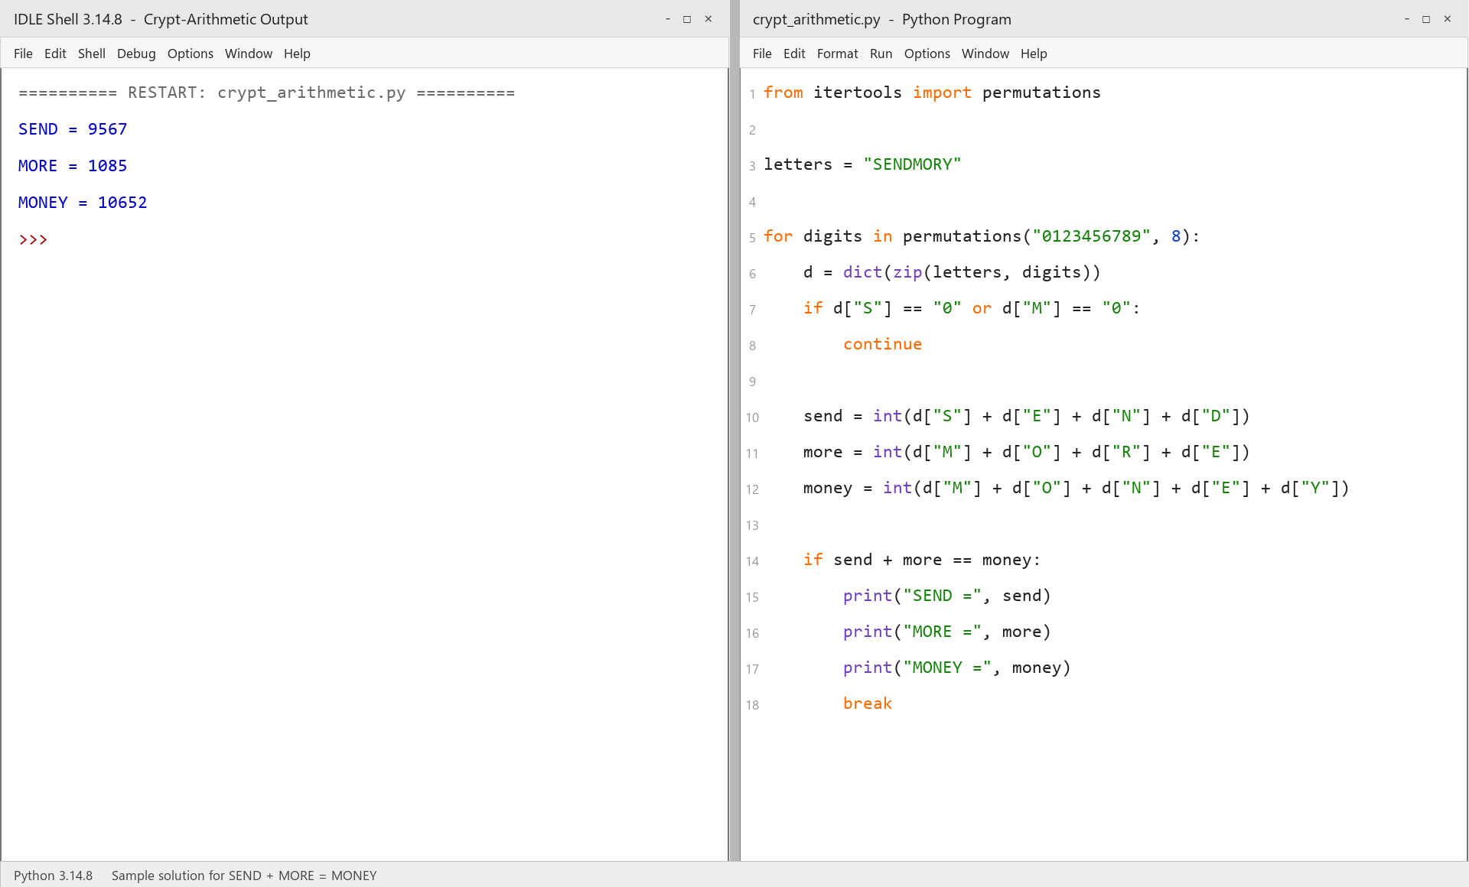
RESULT
Thus, the Crypt-Arithmetic problem was solved successfully using Python.

